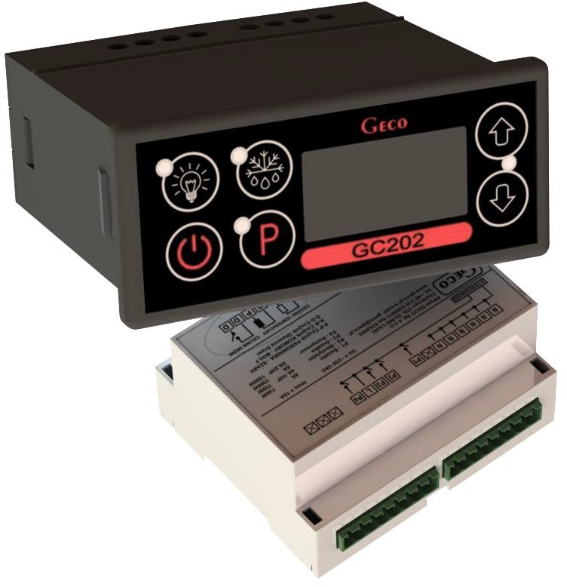
INSTALLATION, OPERATING AND MAINTENANCE MANUAL
GC202
COOLING APPLIANCES CONTROLLER
For software version 01

Please read the manual very carefully before connecting and starting any of our devices.
In case of doubt, please contact our company between 8am and 4pm.

CONTENTS

- GENERAL CHARACTERISTICS 3
- MARKING AND SPECIFICATIONS 3
- HOW TO ORDER 4
- DELIVERY, INSTALLATION AND CONNECTION 5
- PRINCIPLE OF SENSOR ASSEMBLY, TYPES OF COVER SHELLS 6
- MODE OF OPERATION 6
A – General information 6
B – Defrosting 8
C – Principle of operation of the door opening sensor 9
D – HYSTERESIS 10
- DIAGRAMS FOR CONNECTING INDIVIDUAL ASSEMBLIES OF THE DEVICE 10
- SETTING THE SYSTEM PARAMETERS 12
- TROUBLESHOOTING 15
- RETURNS FOR REPAIR 16
- DIAGRAM OF CONNECTION OF DEVICES TO THE CONTROLLER 17
- INFORMATION ON LABELING AND COLLECTION OF WASTE ELECTRICAL AND ELECTRONIC EQUIPMENT 18

GENERAL FEATURES

The Standalone Control Block (SBR) GC202 is a modern, convenient and easy to use device. The Controller is a microprocessor-based device manufactured using Surface Mount Technology (SMT).
Thanks to the two-piece housing, the GC202 can be used for any piece of furniture and a simple cold room. Operating under a safe 12V voltage, the control panel can be mounted anywhere, without need for cutting additional holes and guiding many power-supply cables far from the controlled appliances.
GC202 is able to work with two temperature sensors as standard and, depending on the configuration of the parameter, a third temperature sensor or a door opening (magnetic or optical) sensor can be connected to the controller. All sensors are connected to the executive module and they work under a safe 12V voltage. The controller module also has four outputs enabling direct connection of devices operating at 230V with the load capacity as in Table 1.
As standard, the controller is equipped with sound signalling which is activated when any button on the keypad is pressed and when an alarm goes off.
In order to provide the user with the comfort while using the controller, capacitive (touch) buttons have been used in the keypad.
GC202 stabilises the temperature and controls automatic defrosting, the period of which can be adjusted to specific environmental conditions. It also has a button for manual defrosting of the evaporator.
The controller panel is additionally equipped with a lighting button (depending on the keypad version) operating independently of the main switch.
This thermostat does not require any special maintenance; the keypad is made of plexiglass resistant to high temperatures and most chemicals. It is not permitted to clean it with sharp objects. It suffices to wipe the panel front with a damp cloth from time to time.

MARKING AND SPECIFICATIONS

Model designation: GC202.0X
0X – number denoting the controller version
  - – 3-relay controller controlling the following devices:

compressor/fan/heater or valve.
The keypad of the controller panel is made without the light button.
The standard DD input allows the connection of an additional sensor, the selection of which depends on the r6 parameter. Depending on the setting of this parameter, we can connect a door opening (mechanical or magnetic) sensor or an additional temperature sensor acting as a thermometer (for r6=3).
  - – 4-relay controller controlling the following devices:

compressor/light/fan/heater or valve.
The keypad of the controller panel is made with a light button.
The standard DD input allows the connection of an additional sensor, the selection of which depends on the r6 parameter. Depending on the setting of this parameter, we can connect a door opening (mechanical or magnetic) sensor or an additional temperature sensor acting as a thermometer (for r6=3).

  - – 4-relay controller controlling the following devices:

compressor/light/fan/heater or valve.
Controller panel keypad made with light button.
The standard mounted input 1-2-3 allows the connection of an additional sensor, the selection of which depends on the r6 parameter. Depending on the setting of this parameter, we can connect an optical door opening sensor or an additional temperature sensor acting as a thermometer (for r6=3).

Operating voltage | 230V +10% -15%
Operating temperatures | +5ºC to +40ºC
Relative humidity | 20% to 80% RH
Ingress protection | IP65 at the front of the control panel
Type of temperature sensors | NTC 2,2kΩ – measurement range: -40⁰C to +60⁰C

Table 1: Designation of relays and output loads

EXIT | RELAY | RECOMMENDED MAXIMUM CONTINUOUS LOAD
P1 – Compressor | 30A | 8A | 2HP | 1500W
P2 – Light | 8A | 4A | - | 750W
P3 – Fan | 16A | 4A | 1HP | 750W
P4 – Heater / Valve | 8A | 8A | - | 1500W

Attention!!!
- Currents given in the table are the currents consumed by individual devices during normal operation and include the starting currents of these devices!!!
- The total current consumed simultaneously by the devices must not exceed 10A!!!

ORDERING INFORMATION

The order should specify:
- Full name of the controller, e.g. GC202.02
- Length of the ribbon connecting the executive module and the keypad panel (the standard length of the ribbon is 1m).
- Length of temperature sensors (standard sensor lengths are 2.5m and 3.0m).
- Length of the cable to the door opening sensor (standard: to the reed switch 2.0m; to optical sensor 2.5m).
- Type of fully contactless door opening sensor:

  - magnetic sensor with range of 1-2cm,
  - optical sensor with a range of 1-2cm.

DELIVERY, INSTALLATION AND CONNECTION

- Cut a hole measuring 20x30mm in the designated place in the device, and if the panel masking is not used, the hole should be 58x109mm.
- The executive module should be placed on the rail and locked with a latch.

In the case of shop devices, it is REQUIRED to mount the SBR executive module with the mounting strip facing down!!!
- Any metal elements through which the GC202 or its cables are passed should be filed down or otherwise secured. It is not permitted to mount the GC202 allowing the direct impact of water on it (e.g. water condensing on the lower cover of the display case), touching the evaporator drain pipe, etc. and causing significant changes in its temperature in relation to the ambient temperature (e.g. mounting in the immediate vicinity of the compressor and its accessories, cooled and heated elements).
- Cut the ribbon connecting the panel with the executive module to the desired length plus 2-3cm. Then, after putting it through all the passages, cut its ends again at a right angle and clamp the plugs on it so that the end of the ribbon is hidden inside them for about 0.5mm. The ribbon must be introduced perpendicularly to the plug and tightened without the possibility of any twisting or non-parallel arrangement. For connecting the ribbon to the connectors see Fig. 3.
- After mounting the GC202, connect the power cables in accordance with the description on the module nameplate. Depending on the GC202 version, some outputs may be unused – an X will be inserted in their place – no wires must be connected to these outputs!!!
- The connectors used are certified for a continuous load of 16A!!! They use a fine-pitch thread and special plates to prevent cutting wires, so even a slight tightening results in maximum good contact, and the use of greater force can lead to thread breakage. As a result, the socket may melt and a short-circuit may occur!!!
- All cable surpluses are shortened by cutting or rolling and fastening them with special plastic ties. The cables must be securely fastened along their entire length and must not touch the compressor and its accessories.

After connecting the device to the power supply, there may be voltage on the lighting cable, regardless of switching the device on or off with the button, therefore the starter or fluorescent lamp can be replaced only with the power cord disconnected from the socket!!!

THE SAME CONDITION APPLIES TO ANY OTHER REPAIRS!!!

- If heaters are used, their power must be selected so that in the event of a failure of the GC202 or the contactor and switching them on permanently, there is no possibility of fire or destruction of the device. If high-power heaters are used, it is absolutely necessary to use a safety thermostat on the evaporator; this thermostat should operate differently, e.g. a mechanical thermostat.

INSTALLATION OF SENSORS, TYPES OF COVER SHELLS

- For each type of manufactured device, the place of mounting the chamber and evaporator sensor, as well as the SBR setting should be selected experimentally. It is absolutely forbidden to change the place or method of mounting the sensors and SBR settings without conducting new tests regarding temperature stabilisation and defrosting of the device!!!
- The chamber sensor must be attached in such a way that it does not touch the food and is not exposed to damage while cleaning the device. A special plastic holder can be used to attach this sensor. This solution causes a quick reaction in the sensor (time delays on/off, see VI p.5) and the entire thermostat to the change of air temperature in the device. If it is advisable or necessary to slow down and “smooth” the reaction time of the sensor to temperature changes, we suggest screwing it to a metal element of the device.
- The evaporator sensor should be mounted in a way that ensures maximum solid and reliable contact with the evaporator lamella and in such a place where the ice stays the longest during defrosting. Its attachment should prevent it from being pushed out by accreting ice. Sensors should be mounted vertically, if possible, with the cable coming out at the bottom of the sensor.
- The sensor cables can be shortened or extended in any way, however, observing the following rules:
  - do not cut the sensor cable at a distance of less than 0.5m from the shell
  - it is not recommended to extend the sensor cable beyond 20m.
  - THE WAY OF CONNECTING THE SENSOR CABLES TO THE SENSOR TERMINALS OF THE ACTUATOR MODULE IS FREE!!! (similar to the method of inserting the plug into the ~230V socket)
  - to extend the cables, we suggest using an OMY 2x0.5mm cable
  - connection of the cables in the case of extensions should be done very carefully, each of the pairs of wires is soldered and heat-shrinkable sleeves are put on them. Then, the connection point should be flooded with waterproof silicone and another heat-shrinkable sleeve should be clamped on it.
  - ends of the wires connected to S.B.R. should be tinned.

GENERAL OPERATION PRINCIPLES

A – General information

Start after power on
After connecting the device to the power supply, a 3-second starting procedure is performed, during which three dots will light up on the display for one second, the controller program version for another second, and three dots again. During this time, none of the controlled devices is switched on.
If the device was turned on before a power failure, after the start-up procedure is completed, the device is turned on and the temperature value appears on the display. If an additional temperature sensor is connected, its indication will appear on the display. It does not affect the operation of the device, but only serves as an electronic thermometer. In the absence of this third sensor, the temperature value from the chamber sensor is displayed.
If the device was switched off, it remains switched off and three horizontal lines appear on the display. It is turned on after pressing and holding the button for 5 seconds.

Button functions
– Pressing and holding for 5s turns the controller on/off. As the button is held down, an ascending beep is generated. The off state is signalled by three horizontal lines on the display.
Pressing turns the lighting on or off. This is signalled by a green LED next to the button.
The button works independently of the thermostat switch – .
This is used to activate defrosting manually.
- This is used to enable setting programming and to end programming.
- This is used to increase the set temperature during programming and to enable the evaporator temperature preview. To enable the evaporator temperature preview, hold the button longer, then the display will start flashing and indicate the reading. After 5 seconds, the GC202 will automatically return to reading the temperature of the chamber or the additional temperature sensor. Attention!!! The preview is also active during defrosting, when 'dF' is lit on the display.

- This is used to reduce the set temperature during programming and to enable the preview of the chamber temperature when working with an additional temperature sensor, as well as during defrosting, when 'dF' is lit on the display. By briefly holding the button, the display will start showing (without blinking) the temperature of the chamber, and after 5 seconds GC202 will automatically return to displaying 'dF'.

Temperature setting programming
After pressing the button, programming mode is entered, the display shows the setting value and the LED next to the button lights up.
Pressing or changes the setting value in the range of 'd0' to 'd1'.
Pressing saves the settings and the controller returns to normal operation.

If the GC202 is turned off during programming, it will not remember the new temperature setting!!!

- Compressor operation indication
Compressor activation is indicated by lighting of a small red diode (dot) in the lower right corner of the temperature display. This allows easier checking of possible system malfunctions.
Should the compressor be switched on, but it is not due to the activation of one of the protections (see point 5), the dot indicating the compressor operation will blink. After the set protection time has elapsed, the dot will light up permanently and the compressor will be turned on.

Compressor protection
The delay in switching on the compressor after reaching its activation temperature (temperature set by the user minus the lower hysteresis value) is 30 seconds. If the temperature drops during this time, the 30 second condition will be checked again.

This is to protect the compressor from unnecessary activation, for example caused by putting goods in, draughts, etc.
Every time the temperature setting is reached (the user temperature setting plus the upper hysteresis value) and after every power outage or drop below 175V, the GC202 allows the compressor to be re-activated for the time determined by the 'c02' parameter. However, if 'c02'=0min., the compressor starts after 30 seconds.
After switching on the device with the button, there is a 5-second delay in switching on the compressor. Please note that this will cancel all other protections, including the time set by 'c02' after the compressor has been turned off before. This allows quicker checking of the compressor operation.

Sensor alarms – A1, A2 and A3
The Controller is equipped with alarms indicating sensor failures. The behaviour of the controller will be different depending on which sensor has been damaged.
Damage to the sensor is signalled by the appearance of a relevant message on the display along with a beep. After pressing any button, the alarm signal is silenced.
If the A1 alarm occurs, it is displayed instead of the chamber temperature or the temperature from the additional sensor. In the case of the A2 alarm, the message is displayed alternately with the temperature in the chamber or with the temperature from the additional sensor. When the A3 alarm is activated, it is displayed alternately with the chamber temperature. If the three sensors fail simultaneously, the alarm messages are displayed alternately. The same happens when there are two alarms in the configuration: A1 and A3 and A1 and A2. When there is a failure from the evaporator probe and the additional temperature probe, the A2 and A3 alarms are displayed alternately along with the temperature of the chamber.
A1 – Damage to the chamber temperature sensor. GC202 will turn on the compressor in a time cycle (so-called timer control) according to the times specified in the 'c08' and 'c09’ parameters. Defrosting will operate normally.
A2 – Damage to the evaporator sensor. Manual and automatic defrosting operation is blocked!!! The only way to defrost the device is to turn it off with the button and wait for the ice to melt naturally.
A3 – Damage to the additional temperature sensor. If the parameter is r6 = 03, the sensor damage alarm will be signalled. If we change the parameter to r6 = 00, then the function of the third sensor (also the door opening sensor) will be disabled and the controller will not report an alarm.

Fan control based on evaporator temperature
If the 'd6' parameter is set to a value lower than 40ºC, the controller shuts down the fan when the evaporator temperature is higher than the 'd6' parameter value. This function is not available in the defrosting mode.

B – Defrosting
- If additional defrosting is required due to difficult working conditions, press the button. The green LED on the button will then be on continuously and the display will show 'dF' instead of the temperature measurement, at which point the device will enter the defrosting cycle.
- If the 'c00' time has elapsed since the last defrosting activation and the compressor is running at this moment, the automatic defrost activation will be delayed until the compressor is deactivated as a result of reaching the set temperature or exceeding the maximum operating time specified in the 'c05' parameter.

- If defrosting takes place and the temperature on the evaporator is higher than the value set in the 'd2' parameter, the device will enter the defrosting exit phase after about 10 seconds and once completed, it will resume operating.
- If defrosting occurs and the temperature on the evaporator is lower than the value set in the 'd2' parameter, the GC202 will start defrosting and after reaching the temperature specified in the 'd2' parameter, it will enter the defrosting exit procedure (this state is signalled by the blinking of the green diode on the button), in the version with heaters, the defrosting exit procedure is performed, consisting of two successive phases:
  - dripping phase – in which the compressor and evaporator fans are off for the time set by the 'c03' parameter
  - evaporator freezing phase – in which only the compressor operates in order to lower the evaporator temperature to the temperature defined by the 'd5' parameter before restarting the fans. The maximum and non-extendable freezing time, regardless of the evaporator reaching the 'd5' temperature, is defined by the 'c04' parameter.
- The procedure of exiting the defrosting is completed by starting the fans, turning off 'dF' on the display and switching off the blinking of the green LED on the button.
- In the absence or non-connection to S.B.R. fans, the system will behave as if they were installed.
- Defrosting will be completed after reaching the temperature set in the 'd2' parameter on the evaporator or after exceeding the time set in the 'c01' parameter.
- After switching off 'dF' and the end of defrosting, the display will show the temperature stored just before the start of defrosting for the time specified in the 'c07' parameter – this is to prevent complaints due to “rapid temperature jumps in the device”'.
- The system behaves in the same manner for manual and automatic defrosting.
- The 'r0' parameter allows forcing the fan into the switch-on mode during defrosting.
- The fan cannot be adjusted using the 'd6' parameter during defrosting.

C – Door opening sensor operating principle
- If the door is opened, the fan stops immediately and in GC202, depending on the setting of the 'r7' parameter, the light may be turned on. The temperature reading is shown in the display. If the opening of the door is a cause of the light being switched on, the diode next to the button does not light up.
- The door opening sensor can also switch on the light when the controller is off (three horizontal lines on the display). The word 'dr' will then be displayed without a beep.
- After 30 seconds, if the door has not been closed, the word 'dr' is displayed continuously on the display. There is a short beep that is repeated every 30 seconds.
- If the door has still not been closed after the time specified in the 'r8' parameter, the alarm is activated, signalled by the flashing of the display with the word 'dr' and a beep. At the same time the compressor is switched off.
- If, after opening the door, r8 = 0 the alarm is immediately activated.
- You can cancel the alarm by pressing any key. Closing the door deactivates the alarm and restores normal operation.
- The controller allows the connection of a mechanical, magnetic and optical door opening sensor, depending on the version of the controller.

If the parameter is r6=01, the sensor is closed when the door is opened, while if the parameter is r6=02, the sensor is open when the door is opened.

D – HYSTERESIS
When programming the 'd0' and 'd1' parameters (the minimum and maximum temperature that can be set by the customer), remember that the 'd3' hysteresis value causes an additional 'pull' of the temperature down and up from the temperature set by the user.
This is of particular importance in the case of devices 'plus', which should always work above 0ºC.

Example:
As a manufacturer of a cooling appliance, in this case a cooling counter (positive temperatures), we require that the device enabled operation be only within the range of temperatures that do not exceed the below specified values: Switch off min.: 2ºC. Switch on max.: 10ºC

Symmetrical hysteresis for even values of 'd3' | Symmetric hysteresis for odd values of 'd3'
Example 1.  For example, the 'd3' hysteresis is set to: 2ºC.  For the above hysteresis setting you should also set the parameters:  'd0' at 3ºC and 'd1' at 9ºC | Example 3.  For example, the 'd3' hysteresis is set to: 3ºC.  For the above hysteresis setting you should also set the parameters:  'd0' at 3ºC and 'd1' at 8ºC
Example 2.  For example, the 'd3' hysteresis is set to: 4ºC.  For the above hysteresis setting you should also set the parameters:  'd0' at 4ºC and 'd1'at 8ºC | Example 4.  For example, the 'd3' hysteresis is set to: 5ºC.  For the above hysteresis setting you should also set the parameters:  'd0' at 4ºC and 'd1‘ at 7ºC

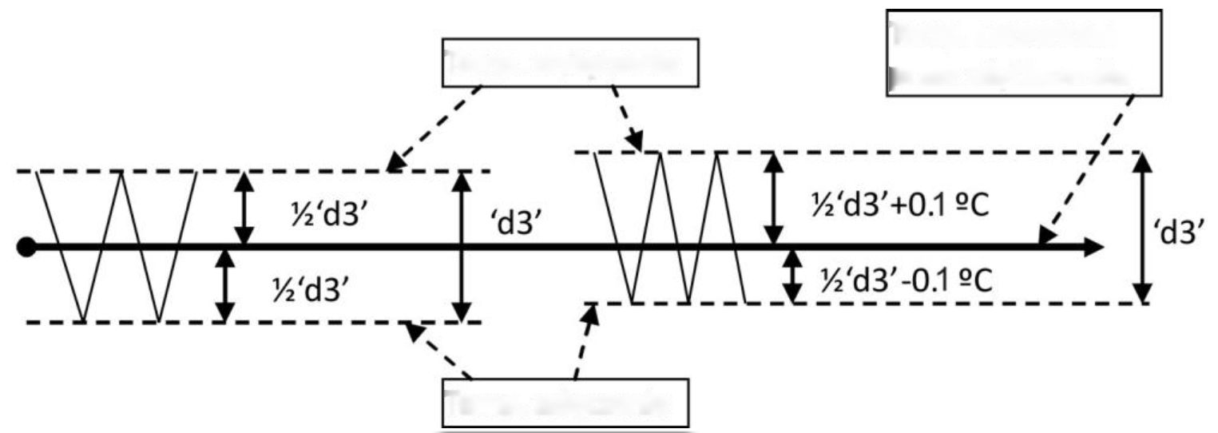
Switch off temp.
Temp. set by the user
Switch on temp.
Fig. 1. Hysteresis principle of operation.

ON/OFF DIAGRAMS FOR INDIVIDUAL ASSEMBLIES OF THE APPLIANCE
A bold line means turning on, and a thin line turning off individual devices. Defrosting exit consists of two phases – see chapter VI p. B-Defrosting.
The “Downtime” field means switching off, and “Work” – switching on of the compressor due to exceeding the programmed temperature, of course, taking into account the value of the programmed hysteresis, parameter 'd3'.

The heater on “diagram 1” is for heating the tray and/or the evaporator water drain hose, and the heater on “diagram 5” is for heating the evaporator water drain hose only.

- ERROR IN PARAMETERS SETTING WILL RESULT IN WRONG OPERATION OF THE DEVICE!!!

The first 6 graphs refer to setting the parameter 'r0' = 00 – the fan is switched on during defrosting.

1. Defrosting by compressor stoppage 'r1'=01, fans run only together with compressor 'r2'=00,
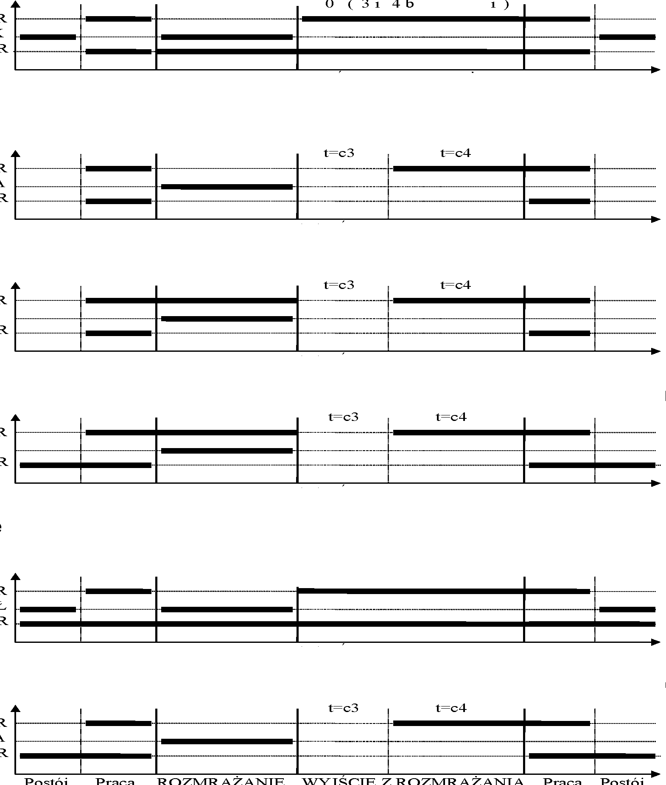
COMPRESSOR
TRAY HEATER
FAN
Stop
Work
DEFROSTING
EXIT DEFROSTING
Work
Stop
t=0 (c3 and c4 irrelevant)
2. Heater defrosting 'r1'=02, fans run only together with the compressor 'r2'=00
COMPRESSOR
HEATER
FAN
Stop
Work
DEFROSTING
EXIT DEFROSTING
Work
Stop
3. Warm vapour defrosting 'r1'=03, fans run only together with the compressor 'r2'=00
COMPRESSOR
VALVE
FAN
Stop
Work
DEFROSTING
EXIT DEFROSTING
Work
Stop
4. Warm vapour defrosting 'r1'=03, fans run all the time when the device is on 'r2'=01
COMPRESSOR
VALVE
FAN
Stop
Work
DEFROSTING
EXIT DEFROSTING
Work
Stop
5. Defrosting by compressor stoppage 'r1'=01, fans run all the time when the device is on 'r2'=01
t=0 (c3 and c4 irrelevant)
COMPRESSOR
DRAIN HEATER
FAN
Stop
Work
DEFROSTING
EXIT DEFROSTING
Work
Stop
6. Heater defrosting 'r1'=02, fans run all the time when the device is turned on 'r2'=01
COMPRESSOR
HEATER
FAN
Stop
Work
DEFROSTING
EXIT DEFROSTING
Work
Stop

The graphs below refer to the 'r0'=01 parameter.
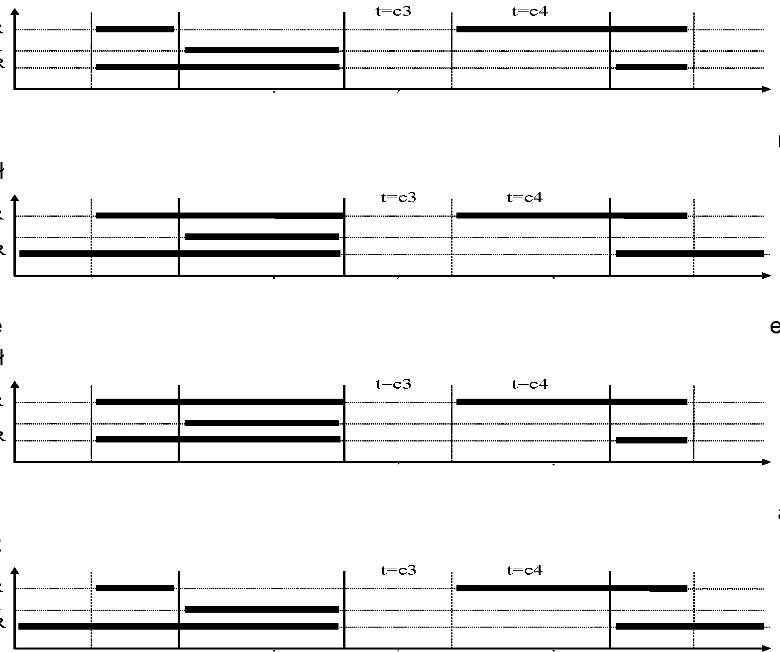
7. Heater defrosting 'r1'=02, fans run only with the compressor 'r2'=00, a fan is on during defrosting 'r0'=01
COMPRESSOR
HEATER
FAN
8. Warm vapour defrosting 'r1'=03, fans run all the time when the device is turned on 'r2'=01, a fan is on during defrosting 'r0'=01
COMPRESSOR
VALVE
FAN
9. Warm vapour defrosting 'r1'=03, fans are on only with the compressor 'r2'=00, a fan is on during defrosting 'r0'=01
COMPRESSOR
VALVE
FAN
10. Heater defrosting 'r1'=02, fans run all the time when the device is turned on 'r2'=01, a fan is on during defrosting 'r0'=01
COMPRESSOR
HEATER
FAN
Stop
Work
DEFROSTING
EXIT DEFROSTING
Work
Stop
Stop
Work
EXIT DEFROSTING
DEFROSTING
Work
Stop
Stop
Work
DEFROSTING
EXIT DEFROSTING
Work
Stop
Stop
Work
DEFROSTING
EXIT DEFROSTING
Work
Stop

SETTING THE SYSTEM PARAMETERS

Once the device is started and checked for proper operation (default settings are factory set) you can begin to enter the system parameters of the GC202.
To do this, turn off the device with the button (three horizontal lines will appear on the display). Then press the and and and while holding them press the button (a short beep will be activated). Keep all three buttons pressed together for approx. 5 seconds. Releasing any of the keys during that period will cause exiting the programming mode. After
After doing this, the LEDs on the and buttons should start flashing and the display will show 'c0' for one second. Then the previously set value for the parameter will be shown. Now use and to enter the required settings; each longer holding
the button will cause fast “scrolling” of the indications. Then press to accept the entered data and move on to entering the next parameter.
It is possible to introduce partial settings, if you do not want to change a given setting, press and GC202 will go to the next parameter.
After entering the setting of the last parameter and accepting it with the button, the programming mode will be automatically exited and the STANDBY mode will return (three horizontal lines on the display).

If no button is pressed within 20 seconds, the device will exit the parameter programming mode.

ATTENTION !!!

Incorrect change of parameter settings may cause faulty operation of the device!!!

Table 2: Designation of parameters
Parameter | Description | Min. | Max. | Step | Factory setting
C00 | How often defrosting should take place Attention!!! If this parameter is set to “0”, there will be no automatic defrosting, only manual defrosting!!! If this parameter is set to “-01”, there will be no automatic or manual defrosting!!! | -01 | 24 | 1h | 6h
C01 | Maximum defrosting time if the evaporator does not reach the set temperature (parameter d2) Attention!!! If this parameter is set to “-01”, there will be no time limit | -01 | 99 | 1min | 30min
C02 | Minimum compressor downtime duration | 0 | 15 | 1min | 3min
C03 | Evaporator dripping duration | 0 | 15 | 1min | 2min
C04 | Evaporator freezing time, after which the fans will start, regardless of whether the evaporator reaches the temperature set in the 'd5' parameter | 1 | 25 | 1min | 10min
C05 | Maximum compressor operation duration  0 – means there is no test (the parameter is disabled) | 0 | 99 | 1min | 40min
C06 | Compressor downtime duration after activation of protection set in parameter 'c5' | 0 | 99 | 1min | 10min
C07 | The time during which, after the end of defrosting ('c4' parameter), the temperature measured just before the start of defrosting will be displayed. | 0 | 60 | 1min | 5min
C08 | Compressor operation time when the control sensor is damaged | 1 | 99 | 1min | 25min
C09 | Compressor downtime when the control sensor is damaged | 1 | 60 | 1min | 5min

d0 | Minimum temperature that can be set by the customer | -40 | 20 | 1°C | 1°C
d1 | Maximum temperature that the customer will be able to set | d0+1 | 40 | 1°C | 10°C
d2 | Evaporator temperature at which the defrosting is finished | 0 | 40 | 1°C | 5°C
d3 | Hysteresis value | 1 | 10 | 0.1°C | 2°C
d4 | Value of the chamber sensor re-scaling from the actually measured temperature | -10 | 10 | 0.1°C | 0°C
d5 | Evaporator temperature at which the fans will start after defrosting | -30 | 10 | 1°C | -5°C
d6 | Evaporator temperature above which the fan is always off.  Setting the parameter to +40°C disables this control. | -40 | 40 | 1°C | 5°C

r0 | Mode of fan operation during defrosting  00 – works according to the diagrams in chapter VII  01 – always on during defrosting  02 – always off during defrosting | 00 | 02 | 1 | 00
r1 | Determining the defrosting method of the evaporator, the parameter is set to:  01 – defrosting by compressor stoppage  02 – heater defrosting  03 – warm vapour defrosting valve (reverse circuit) | 01 | 03 | 1 | 02
r2 | Determining the mode of operation of the evaporator fans, the parameter is set to:  00 – fans work only together with the compressor  01 – fans run all the time after power on  ATTENTION!!! This parameter has no effect on the evaporator defrosting cycle and method | 00 | 01 | 1 | 01
r3 | Determination of the temperature control method, parameter set to:  00 – normal regulation  01 – the temperature is adjusted according to the measurement from the evaporator sensor, the programmed temperature and d0, d1, d2 and d3 parameters apply to the evaporator sensor, the measurement from the chamber sensor is displayed. | 00 | 01 | 1 | 00
r5 | Conditions for defrosting activation during the device start:  00 – start of operation without defrosting  01 – if a power outage occurred during defrosting, defrosting is activated  02 – defrosting after each switching the device on. | 00 | 02 | 1 | 00
r6 | Optional door opening sensor or additional temperature sensor.  00 – no door opening sensor  01 – door opening sensor exists, closed when the door is open  02 – door opening sensor exists, open when the door is open  03 – there is a temperature sensor (thermometer) | 00 | 02 | 1 | 01
r7 | Lighting activation methods:  01 – light controlled only by the door sensor  02 – light controlled only by the keyboard  03 – light controlled by both the door sensor and the keyboard | 01 | 03 | 1 | 03
r8 | Time elapsed after door opening until alarm activation.  30 seconds after opening the door, the word 'dr' is displayed and a short beep is heard, which is repeated every 30 seconds.  After the r8 time elapses, the alarm is activated, signalled by the flashing of the display with the word 'dr' and a beep, and the compressor is turned off.  0 – means immediate alarm activation | 00 | 20 | 1min | 1min

TROUBLESHOOTING

Symptoms | Checks
1. The display does not light up even though the GC202 is connected to the mains | - the presence of 230V voltage on the L and N power terminals  - correct connection of the executive module with the control panel  - pull out and insert the ribbon slots  - connect another ribbon
2. The compressor does not turn on despite signalling its activation – red diode | - presence of 230V voltage on terminals K and N – If present, check the compressor  - if not, check the correct connection of the executive module with the control panel  - connect another ribbon
3. The defrosting heater does not turn on | - presence of 230V voltage on terminals according to the description on the top side of the executive module  - if it is, check the heater  - if not, check the correct connection of the executive module with the control panel  - connect another ribbon
4. The light tube does not go on | - presence of 230V voltage on terminals according to the description on the top side of the executive module  - if it is, check a/ starter, b/ fluorescent lamp, c/ choke or other lighting elements  - if not, check the correct connection of the executive module with the control panel  - connect another ribbon
5. Incorrect temperature reading | - connecting sensors to connectors  - 'd4' parameter value  - correct mounting of the sensor  - condition of the sensor cable – the cable must not have any damage  - Check the exact appearance of the outer surface of the sensor shell to see if it has not been mechanically damaged.
6. It is not possible to set the desired temperature | value of 'd0' and 'd1' parameters (d0<d1)
7. Flashing dots on display, no switching on possible | - supply voltage value  - condition of power connectors  - tightening the power connectors  - correct connection of the executive module with the control panel  - connect another ribbon
8. ‘Abnormal’, ‘strange’ behaviour of the device | - the presence of 230V voltage on the L and N power terminals  - condition of power connectors  - zeroing of the refrigeration unit  - condition of the electrical installation and the number of devices connected to one phase  - do you have the correct type of a thermostat (output label) for your device?  - have the control panel, actuator module or ribbon plugs not been exposed to water or other liquid  - are the control panel, module or ribbon plugs not exposed to moisture or rapid temperature changes

- correct connection of the executive module with the control panel
- connect another ribbon
9. Problems with appliance defrosting | - 'd2' and 'c00', 'c01' parameter value  - 'c01' parameter value This is the maximum defrosting time of the device, regardless of whether the evaporator has reached the programmed defrosting end temperature or not ('d2' parameter). If this duration is too short, the appliance will not be able to defrost completely.  - correct mounting of the sensor to the lamellas of the evaporator.  IT MUST BE FIRMLY MOUNTED AND TIGHTLY ADHERE TO THE LAMELLAS!!!  - if the evaporator sensor is mounted in the place where the ice stays the longest, if not, check the temperature on the sensor when the last ice nuggets fall from the evaporator. THIS TEMPERATURE SHOULD BE ENTERED THEN AS 'd2' PARAMETER
10. The appliance does not reach its set temperature and its cooling function is not working | - what temperature has been programmed by the user  - values of specific parameters, especially the 'c02', 'c05', 'd0', 'd1'  - point 9 – Problems with defrosting the device. If the appliance does not defrost completely, it will not reach its set temperature!!!  - method and place of attaching the chamber sensor  - have the side windows in the rack and the sliding windows in the display case not been dismantled  - MAKE SURE THE DEVICE IS NOT POSITIONED IN A DRAUGHT OR IN THE SUN!!!  - are there no fans or air conditioning installed on or near the ceiling  - condenser cleanliness  - temperature in the store (each manufacturer provides max. operating temperature for the appliance)  - amount of gas, fans, evaporator heater, evaporator drain hose
11. Incorrect operation of the door opening sensor | - 'r6' and 'r7' parameter value  - correct sensor connection  - check the correct connection of the executive module with the control panel  - connect another ribbon

RETURNING FOR REPAIR

PPUH GECO reserves the right to refuse to accept the device for free repair if the seals are found to be broken!!!
P.P.U.H. Geco Sp. z o.o. is not liable for losses and damage resulting from the fact that the manufacturer of the refrigeration device or its service provided the final customer with information on how to make changes to the GC202 system data, incorrect or unprofessional installation, and for losses caused by malfunction of the device.

DIAGRAM OF CONNECTION OF DEVICES TO THE CONTROLLER

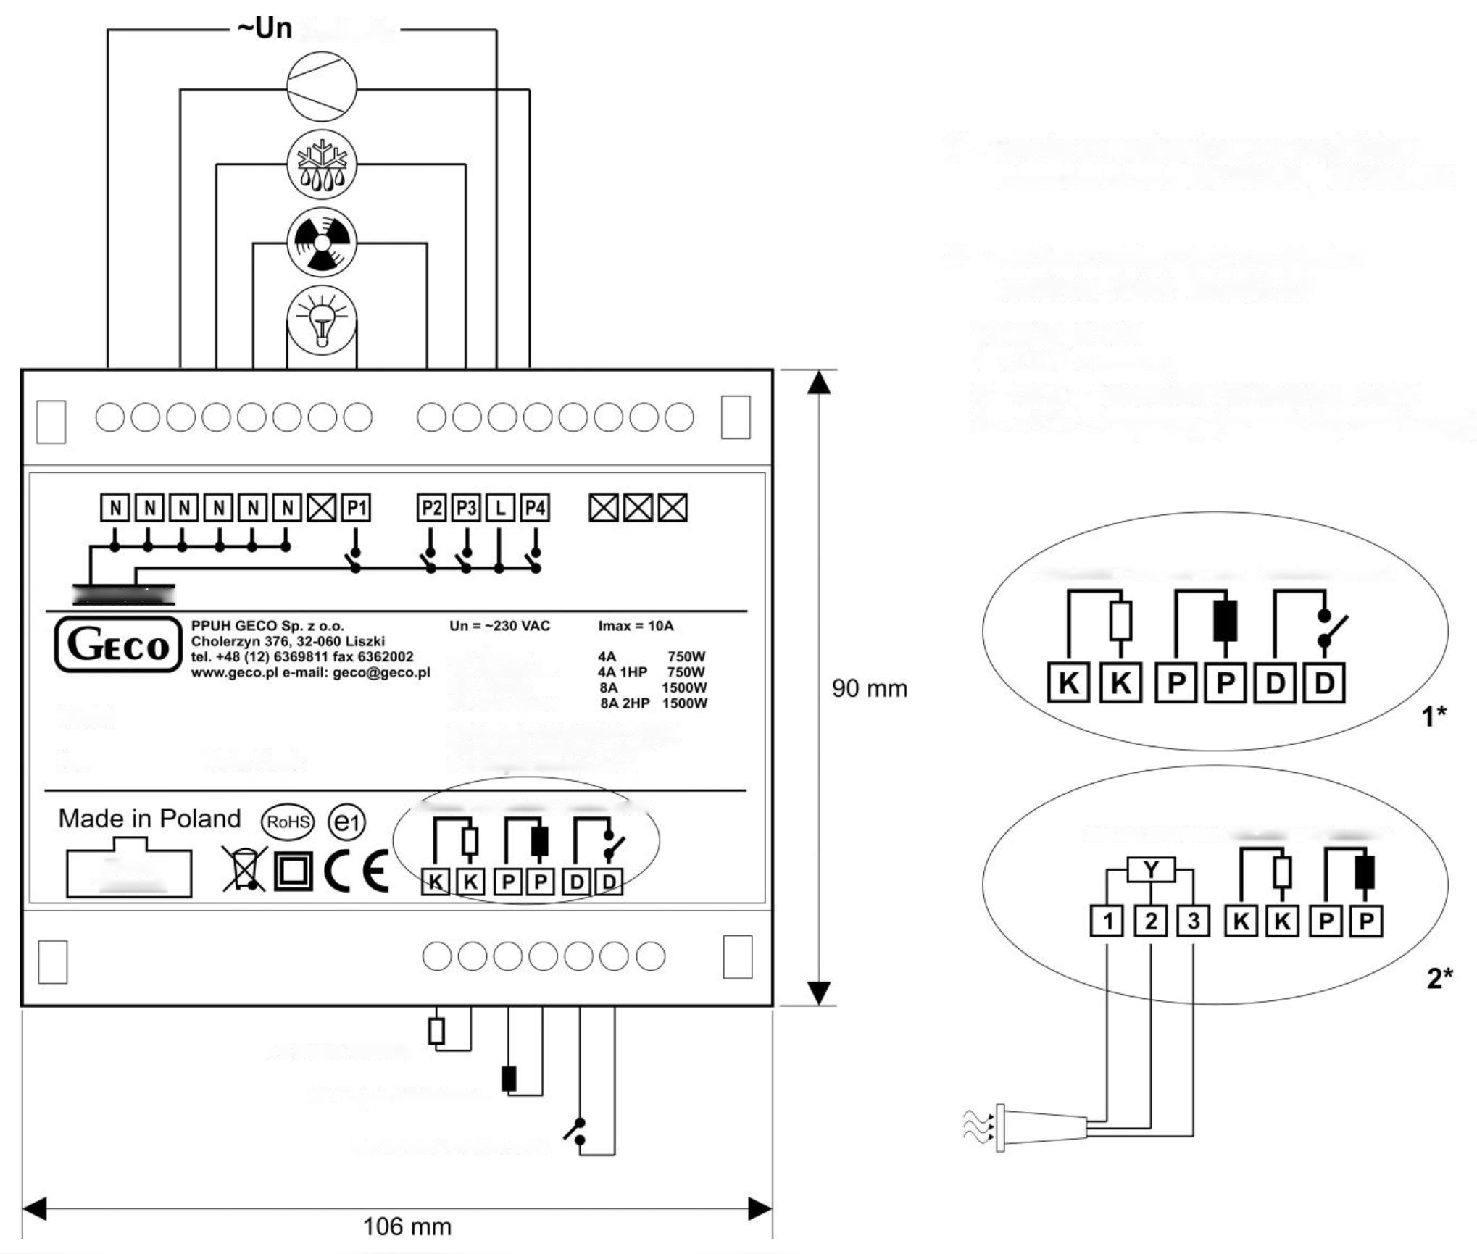
Power supply
1* – version with a mechanical door opening sensor: GC202.01, GC202.02
2* – version with optical door opening sensor: GC202.03
Door sensor:
1 – OUT – black
2 – GND – blue (previously white)
3 – +12V – brown (previously red)
TEMPERATURE SENSORS
DOOR SENSOR
OPTICAL SENSOR
TEMPERATURE SENSORS
Ribbon Connector
Manufacture Date:
Model:
Ns.
CONTROL
P1 – Light
P2 – Fan
P3 – Heater
P4 – Compressor
P-P EVAPORATOR sensor – GRAY
K-K CHAMBER sensor – WHITE
D-D Door Open Sensor
TEMPERATURE SENSORS
DOOR SENSOR
K-K CHAMBER sensor
P-P EVAPORATOR sensor
D-D Door Open Sensor
Fig. 2 Scheme of connecting devices to the main controller module.

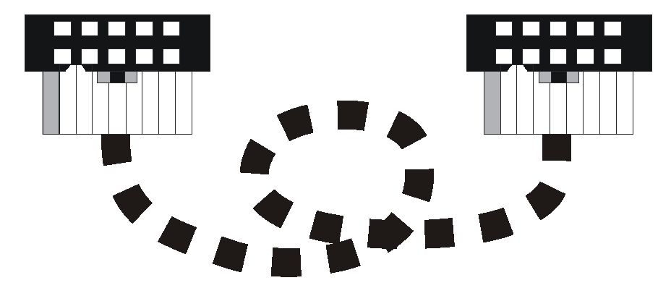 | THE PICTURE SHOWS A VIEW OF THE PLUGS FROM THE SIDE OF THE HOLES AND THEIR RELATION TO EACH OTHER AND THE SELECTED RIBBON STRIP, AFTER THE CORRECT CONNECTION!!!

Fig. 3 View of the ribbon after proper connection.

INFORMATION ON MARKING AND COLLECTING WASTE ELECTRICAL AND ELECTRONIC EQUIPMENT

ATTENTION!

The symbol placed on a product or on its packaging indicates that it is subject to selective collection of waste electric and electronic equipment. This means that the product should not be discarded with other household waste. Appropriate removal of old and waste electric and electronic equipment will prevent potentially harmful effects on the environment and human health.
The obligation of selective equipment collection rests on the user who should deliver the equipment to a collection point.

P.P.U.H. Geco Sp. z o.o.
Cholerzyn 376, 32-060 Liszki, Poland
phone: +48 12 6369811, 6361290
fax: +48 12 6362002
http://www.geco.pl
e-mail: geco@geco.pl

